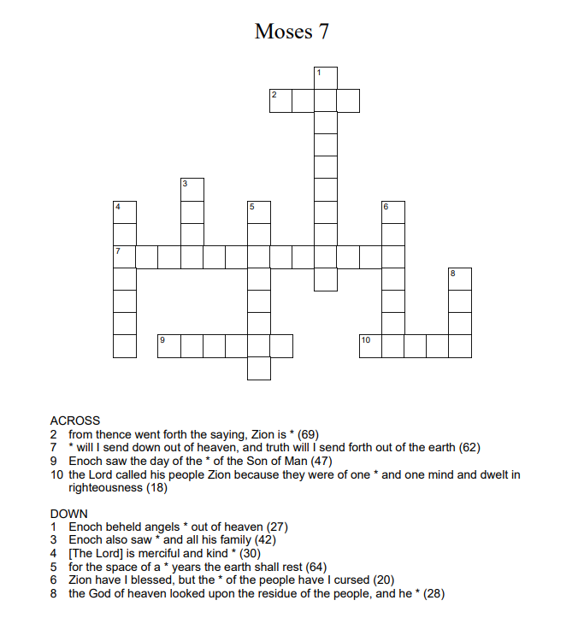

Made at puzzle-maker.comes

