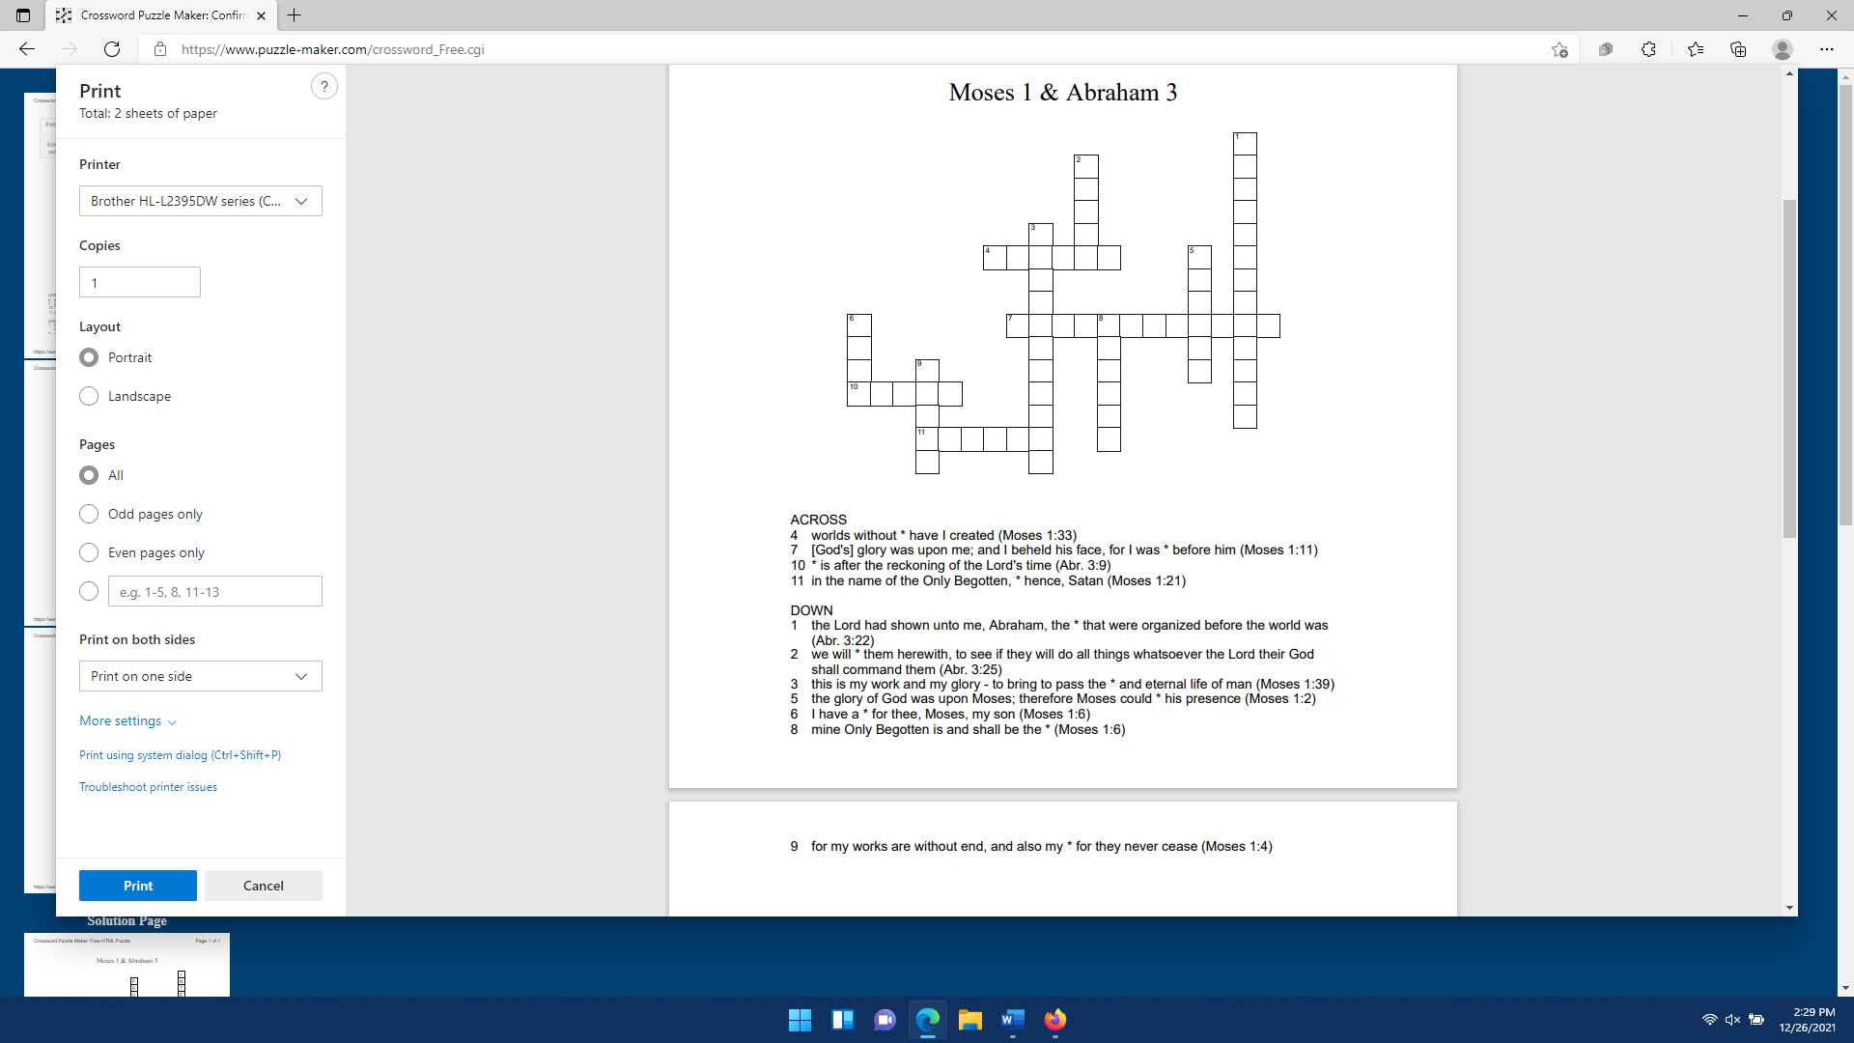
Puzzle made at puzzle-maker.com

